Motor Documentation:

Introduction:
This document presents a comprehensive overview of our project: the design, construction, and testing of a hobby rocket model. Our objective is to reach an apogee of over 1 kilometer, a goal that has necessitated careful consideration of every aspect of our design. The motor, powered by a three-segment KNSU propellant, is the heart of our model. We will delve into the theory behind our design choices, the practicalities of motor construction, and the rigorous testing procedures we have implemented.

Design Theory:
Here’s a list of factors taken into consideration when it comes to the design aspect of the motor:
- Propellent Choice:
In rocketry, the choice of propellant is a critical factor that directly influences the performance and safety of the rocket. For our rocket model, we have opted for Potassium Nitrate-Sucrose (KNSU) as our solid propellant. This decision is underpinned by several key considerations.
Firstly, KNSU is a composite propellant that offers a balance between performance and safety. It provides a reliable and steady burn rate, which is crucial for achieving our target apogee of over 1 kilometer. The specific impulse of KNSU, a measure of its efficiency, is competitive with other solid propellants, making it a suitable choice for our project.
Secondly, the ingredients for KNSU are readily available and relatively inexpensive, making it a practical choice for a hobby rocket. The process of manufacturing KNSU is also less complex compared to other propellants, reducing the barriers to entry for amateur rocket enthusiasts.
Lastly, safety is a paramount concern in rocketry. KNSU is non-toxic and poses fewer risks during the manufacturing process compared to other propellants. Its combustion products are also environmentally friendly.
In conclusion, the choice of KNSU as our propellant is a strategic decision influenced by its performance characteristics, cost-effectiveness, and safety profile.
The balanced chemical equation for the combustion of KNSU propellant is:
65KNO3​+35C12​H22​O11​→K2​CO3​+CO2​+H2​O+N2​+Heat

- Grain Structure:
There’s a variety of grain structures one can opt when it comes to solid-based rocket propellants. The one opted by us was the BATES grain structure. The BATES (Ballistic Test And Evaluation System) grain is a popular grain configuration used in solid rocket motors. Here are some key characteristics and reasons for its widespread use:
- Multiple Segments: A BATES grain typically consists of two or more propellant segments. This multi-segment design allows for a more controlled and predictable burn rate.
- Hollow Cylindrical Shape: Each segment of a BATES grain is a hollow cylinder. This shape provides a large initial burning surface area, contributing to a high initial thrust.
- Inhibited Outer Surface: The outer surface of each segment is usually inhibited or case-bonded. This means that the propellant burns only on the inner surface of the hollow cylinder and the ends of each segment. This design helps maintain a nearly constant burning surface area throughout the burn, leading to a more consistent thrust profile.
- Neutral Burn Profile: Due to the combination of the hollow cylindrical shape and the inhibited outer surface, BATES grains typically exhibit a nearly neutral burn profile. This means that the thrust and chamber pressure remain approximately constant throughout the burn, which is often desirable for rocket performance.
- Flexibility: The BATES grain configuration offers flexibility in adjusting the motor’s performance. By varying the number of segments, their lengths, and the diameter of the hollow core, one can tailor the motor’s thrust-time curve to specific requirements.
In conclusion, the BATES grain configuration is a versatile and reliable choice for solid rocket motors, offering a balance between performance, predictability, and safety.
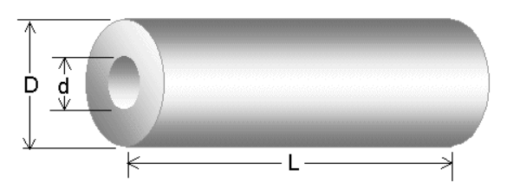

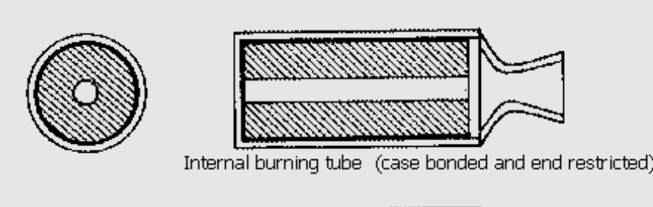

The grain dimensions and parameters considered for our motor are as follows:
D – Outer Diameter – 38.60mm
d – Inner Diameter – 16mm
L – Length of the grain – 95mm

- Nozzle Design:
The Nozzle Design section of our document delves into the intricacies of one of the most critical components of our rocket motor. The nozzle, while seemingly simple in structure, plays a pivotal role in the performance and efficiency of the rocket.
The nozzle’s primary function is to accelerate the combustion gases produced by the burning propellant, thereby generating thrust. The design of the nozzle, including its shape, size, and material, directly influences the exhaust velocity, thrust, and overall motor performance.
In this section, we will discuss the theoretical principles guiding our nozzle design, including the concepts of choked flow, expansion ratio, and thrust coefficient. We will also detail the practical aspects of fabricating the nozzle, including material selection and manufacturing processes.
Through a blend of theory and practice, we aim to provide a comprehensive understanding of our nozzle design and its contribution to our rocket’s performance.
- To get the dimensions of the Nozzle, we used the software OpenMotor. The Divergence Half angle and the Convergence Half angle are supposed to be in the ratio 3:7. Hence, we assumed the values of 15 and 35 degrees and ran the simulations so as to get a peak pressure value close to 1200 psi. The value of peak pressure we obtained was 1269 psi which was in fact close to the expected value, so we decided to go with those values of convergence and divergence half angles. Coming to the throat dimensions, we had known that the port to throat ratio has to be in a range closer to 2. We went with the value of throat diameter to be 11.8 so that the port to throat ratio was close to 2, it was 1.84 and it provided an impulse of 689.91 Ns which was more than sufficient in our case. In case you are wondering how we figured if it was more than enough, wait till the simulation part where we discuss on the OpenRocket software to get an understanding of Max height (Apogee), Thrust vs time graph, etc.
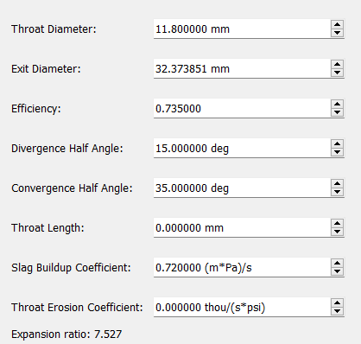
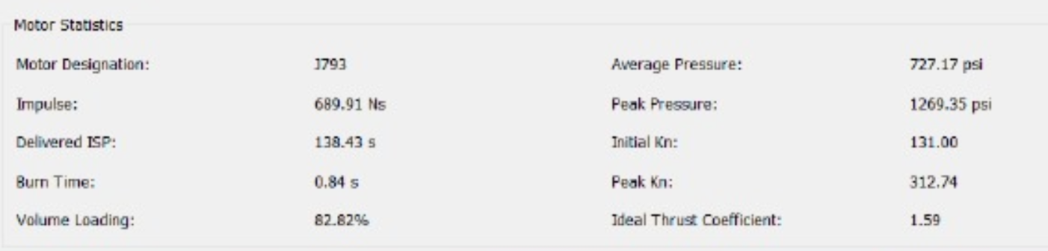

A look into the sketch of the Nozzle design:
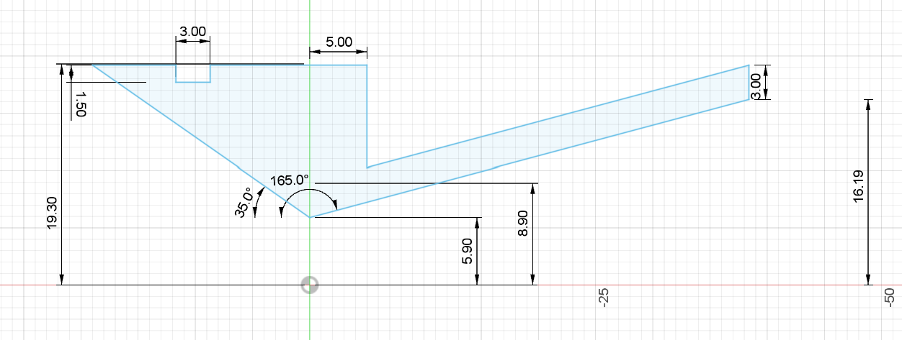
- The sketch and designs were made in the Autodesk Fusion 360 software. Upon completing the sketch, the sketch was revolved so as to create the complete 3D model which resulted to give:
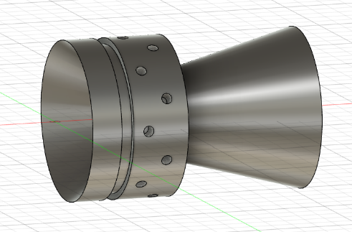
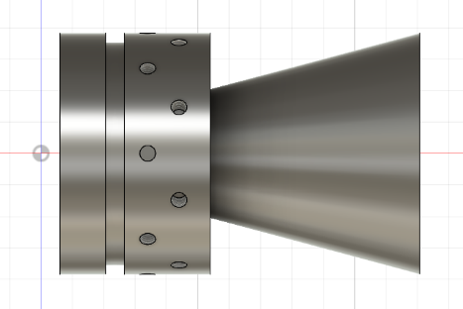
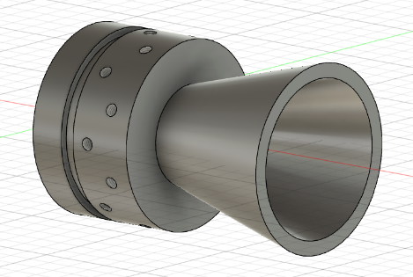

CAD Designs:
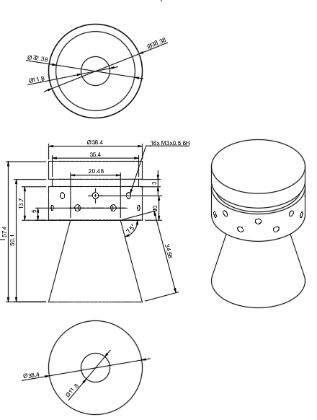
- End Cap Design:
The End Cap Design section of our document focuses on the design and function of the end cap, a crucial component of our rocket motor. The end cap serves as a seal for the motor casing, containing the high-pressure combustion gases produced by the burning propellant.
The design of the end cap is not merely about creating a physical barrier; it’s about ensuring the structural integrity of the motor under extreme conditions, facilitating the ignition process, and contributing to the overall safety of the rocket operation.
CAD Design:
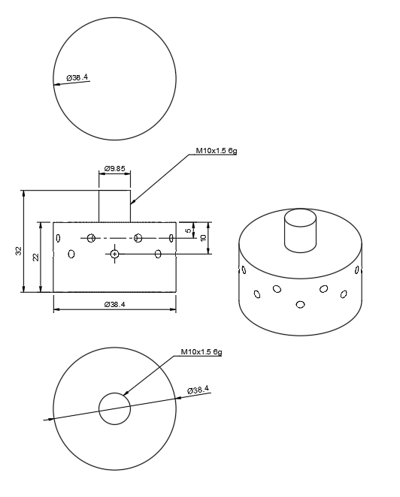
3D Models:

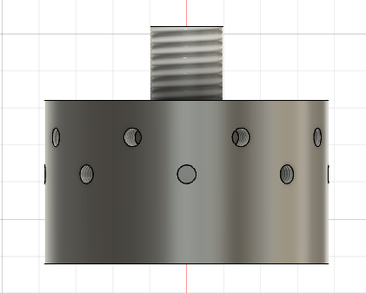
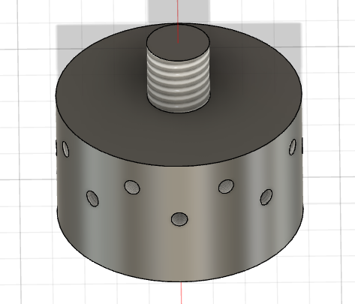
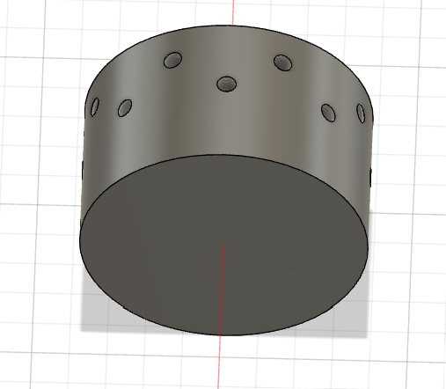

- Casing Design:
The Casing Design section of our document delves into the design and function of the casing, a vital component of our rocket motor. The casing not only provides a physical structure to contain the propellant and other internal components, but it also plays a significant role in the overall performance, safety, and reliability of the rocket motor.
CAD Design:
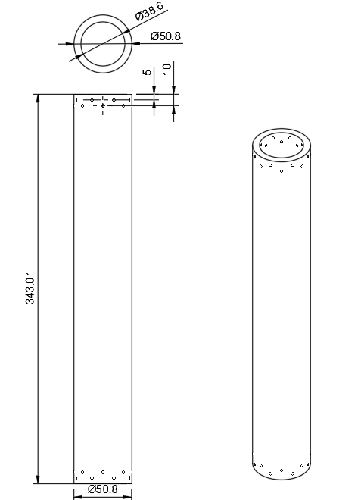

3D Model:

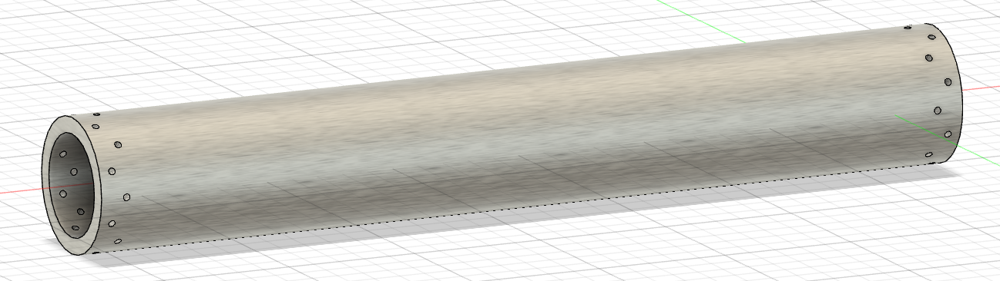

The Rocket Motor:
With all these in place, the assembled Rocket Motor would look like:
